Copilot
The diagram appears to describe a customer technical file request and repository management process, with the goal of directing customers to a self-service repository when files already exist, while creating and publishing missing files when they do not.
Process Brief: IBX Technical File Request Management
Purpose
This process governs how customer requests for IBX (International Business Exchange) technical files are handled. It ensures that existing technical documentation is reused where available and that missing documentation is obtained, stored, and made accessible through a central SharePoint repository.
The intended outcome is a repeatable process that reduces manual effort, promotes self-service, and improves customer access to technical information.

Process Flow
1. Customer Requests an IBX Technical File
The process begins when a customer requests a technical file associated with an IBX site or service.
2. Determine Whether the File Already Exists
A decision point is used to check whether the requested file is already available in the repository.
If YES
- The customer is advised to retrieve the file from the Equinix SharePoint repository.
- The repository assigned to the customer serves as the source of truth.
- The process ends with customer self-service access.
If NO
- The Account Team requests the file from the appropriate Technical Team or directly from the IBX team.
- The technical team creates or locates the required file.
3. Upload File to Repository
- The technical team submits/uploads the file into SharePoint.
- The repository becomes the permanent storage location for future requests.
4. File Availability Confirmed
Once the file is available in SharePoint:
- The customer is directed to the repository.
- Future requests for the same file should follow the "File Exists" route, reducing repeat work.

Intended Business Value
Customer Benefits
- Faster access to technical documentation.
- Self-service retrieval through an approved repository.
- Reduced dependency on account teams for repeat requests.
Operational Benefits
- Eliminates repeated creation or retrieval of the same files.
- Creates a centralised, governed document repository.
- Improves consistency and version control.
- Reduces workload for account and technical teams over time.
Organisational Benefits
- Better knowledge management.
- Improved customer experience.
- Greater scalability as the number of requests increases.

Identified Gaps and Logical Inconsistencies
1. Missing Decision After Upload
The flow shows "Team submits file into SharePoint" with a "YES" branch, but there is no associated decision question.
Recommendation: Add a decision such as:
"File successfully uploaded and available to customer?"
- Yes → Notify customer and direct them to SharePoint.
- No → Return to Technical Team for correction.

2. Customer Notification Not Explicit
After a file is uploaded, the process appears to loop back to the repository path, but it does not explicitly state who informs the customer.
Recommendation: Add a step:
"Account Team notifies customer that file is available in SharePoint."

3. Ownership Is Unclear
It is unclear who is responsible for:
- Verifying file existence.
- Managing SharePoint permissions.
- Ensuring document quality.
Recommendation: Define ownership using a RACI or swimlane model:
- Customer
- Account Team
- Technical Team
- SharePoint Repository Administrator

4. Repository Search Process Not Defined
The decision "We Have File" assumes a reliable method of checking availability.
Recommendation: Add a step:
"Search repository for requested file."
before the decision node.

5. No Exception Handling
The process does not address situations where:
- The technical team cannot provide the file.
- The file is obsolete.
- Customer lacks repository access.
- File approval is required before publication.
Recommendation: Add exception paths for these scenarios.

6. Process End States Are Missing
There are no formal end points.
Recommendation: Add clear outcomes:
- Request Fulfilled via Existing Repository File
- Request Fulfilled via Newly Created Repository File
- Request Unable to Be Fulfilled

Suggested Future-State Process

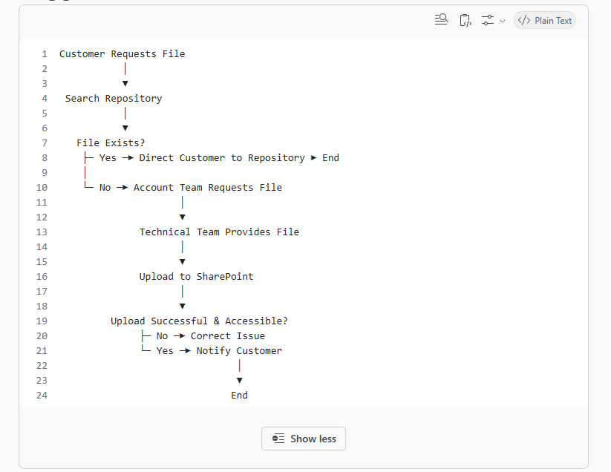

Overall assessment: The process is fundamentally sound and clearly aims to move customers toward a self-service document repository model. The main improvements are stronger ownership definition, explicit customer notification steps, clearer decision points, and exception handling to make the workflow operationally robust and audit-ready.
Provide your feedback on BizChat
You said:
Define ownership roles clearly - Account team is Sales Engineer or Service Manager. Technical Team is the IBX facilities team responsible for the IBX in question.
Copilot said:
Copilot
That clarification helps significantly because it allows the ownership model to be defined clearly and removes one of the major ambiguities in the original process.
Ownership Model
Process Step | Primary Owner | Supporting Owner(s) | Responsibility
Customer requests an IBX technical file | Customer | Sales Engineer / Service Manager | Initiates request for technical documentation.
Check whether file already exists in repository | Sales Engineer / Service Manager (Account Team) | Customer (if self-service search available) | Validates whether the requested file is already stored in the designated repository.
Direct customer to repository | Sales Engineer / Service Manager | SharePoint Administrator (if access issues occur) | Provides guidance to customer on locating the file in the Equinix SharePoint repository.
Request missing file | Sales Engineer / Service Manager | IBX Facilities Team | Raises request for documentation not currently available in the repository.
Create, locate, or validate file | IBX Facilities Team | Sales Engineer / Service Manager | Generates, retrieves, or verifies the required technical file for the specific IBX location.
Upload file to repository | IBX Facilities Team | SharePoint Administrator (if required) | Publishes the approved document to the customer's SharePoint repository.
Verify file availability and access | Sales Engineer / Service Manager | IBX Facilities Team | Confirms successful upload and customer accessibility.
Notify customer | Sales Engineer / Service Manager | N/A | Informs customer that the requested file is available.
Repository administration and permissions | SharePoint Administrator | Sales Engineer / Service Manager | Maintains repository structure, permissions, and access controls.

Updated Process Brief
IBX Technical File Request and Repository Management Process
Purpose
This process provides a structured method for fulfilling customer requests for IBX technical files while building and maintaining a central SharePoint repository. The objective is to maximise customer self-service, minimise repeat requests to technical teams, and ensure technical documentation is consistently available and centrally managed.
Key Roles
Customer
- Requests technical documentation.
- Retrieves documentation from the designated repository.
Account Team (Sales Engineer or Service Manager)
- Acts as the primary customer contact.
- Validates whether requested documents already exist.
- Coordinates requests for new documentation.
- Communicates repository location and file availability to customers.
IBX Facilities Team
- Owns the technical content.
- Produces, validates, and uploads IBX technical files.
- Ensures documentation accuracy for the relevant IBX site.
SharePoint Administrator (where applicable)
- Maintains repository access and permissions.
- Supports document management governance.

Process Flow
1. Customer Request Received
A customer requests a specific IBX technical file from the assigned Sales Engineer or Service Manager.
2. Repository Check
The Account Team checks whether the requested file already exists within the customer's designated Equinix SharePoint repository.
3. File Available?
Yes
- The Account Team directs the customer to the repository.
- The customer accesses the document directly.
- Process complete.
No
- The Account Team submits a request to the relevant IBX Facilities Team.
4. Technical File Creation or Retrieval
The IBX Facilities Team locates, validates, or creates the required technical documentation.
5. Repository Publication
The IBX Facilities Team uploads the file into the appropriate SharePoint repository for the customer.
6. Validation and Customer Notification
The Account Team confirms that the file is available and accessible within SharePoint and notifies the customer where to find it.
7. Future Requests
Subsequent requests for the same file should follow the repository access path, reducing operational effort and increasing self-service adoption.

Value Delivered
Customer Value
- Faster access to technical documentation.
- Consistent self-service experience.
- Reduced dependency on manual fulfilment.
Operational Value
- Reduces repetitive requests to IBX Facilities Teams.
- Establishes SharePoint as the single source of truth.
- Improves document discoverability and version control.
- Creates a reusable knowledge repository for future customer needs.
Business Value
- Improves customer satisfaction through faster fulfilment.
- Reduces operational workload for Sales Engineers and Service Managers.
- Supports scalable management of technical documentation across multiple IBX locations.

Recommended Process Enhancements
- Add an explicit step: "Customer notified that file is available."
- Add a validation checkpoint: "File uploaded successfully and customer has access?"
- Define repository ownership and document review cycles.
- Measure success through:
  - Percentage of requests fulfilled from SharePoint without technical team involvement.
  - Average request fulfilment time.
  - Growth in repository utilisation.
  - Reduction in repeat document requests.
This positions the Sales Engineer or Service Manager as the workflow owner, while the IBX Facilities Team remains the technical content owner, creating clear accountability throughout the process.
Provide your feedback on BizChat
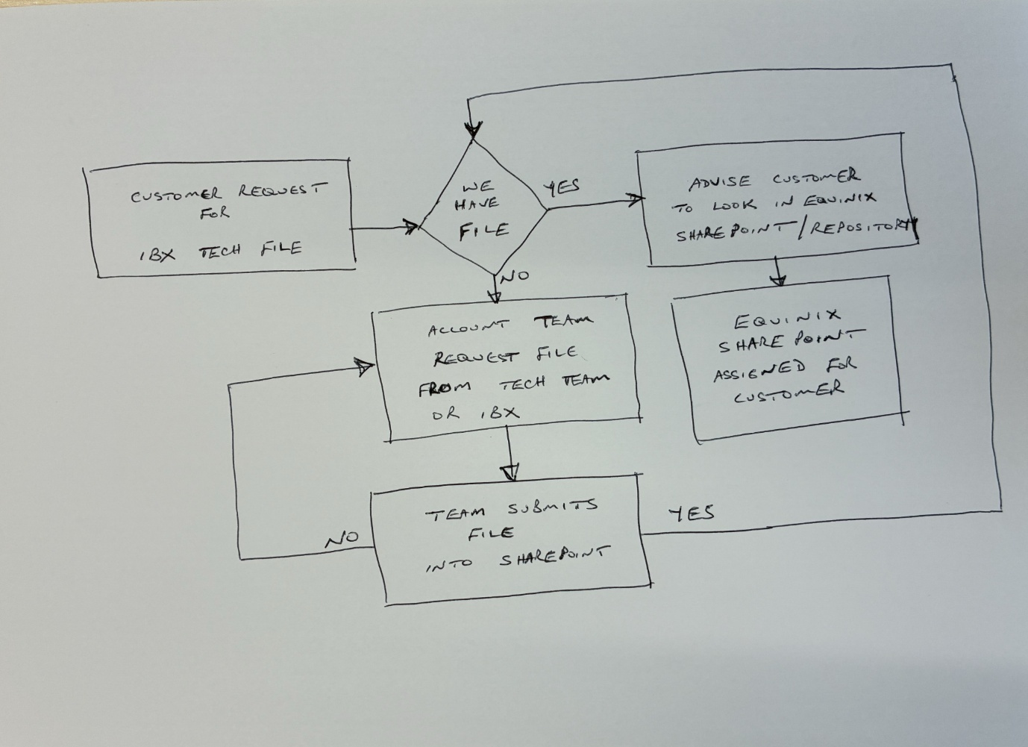
You said:
Add a diagram of the updated flow
Copilot said:
Copilot
Below is a clean version of the updated process flow, incorporating the clarified ownership model and the missing validation/notification steps.
Updated Process Flow Diagram

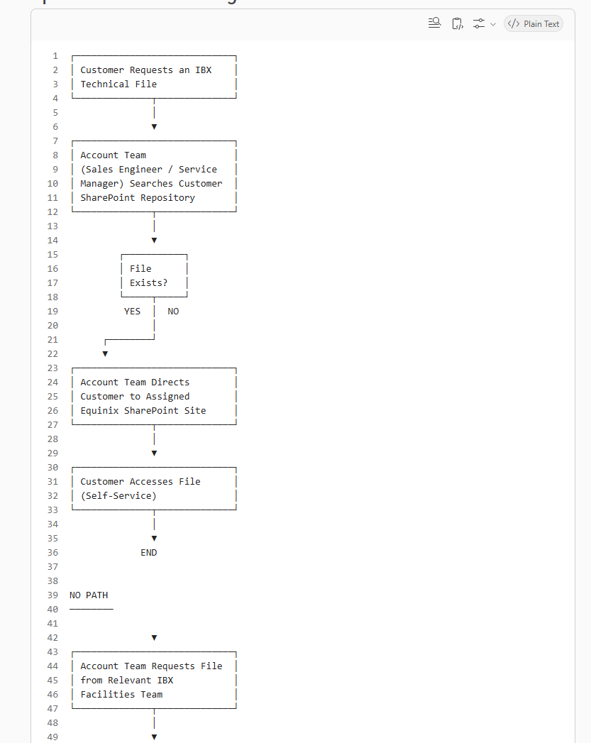
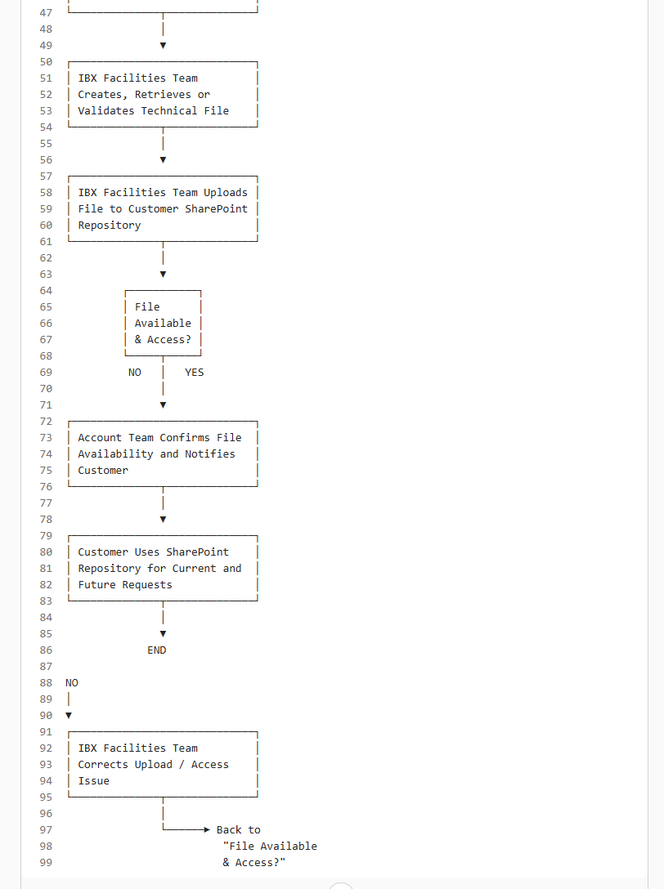

Simplified Swimlane View

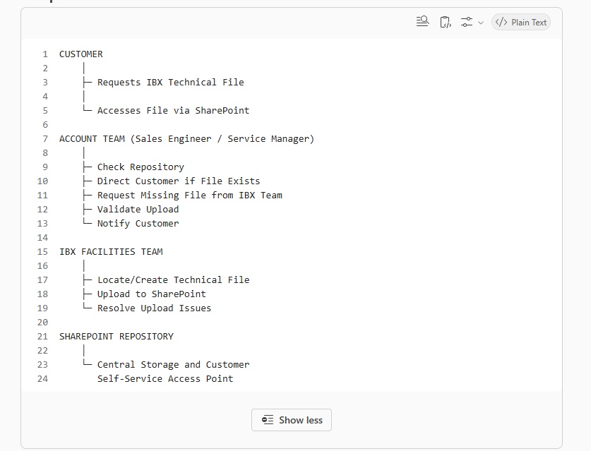
Key Principle
The Sales Engineer or Service Manager owns the customer fulfilment workflow, while the IBX Facilities Team owns the technical content. SharePoint acts as the single source of truth for all approved customer-facing IBX technical files.
Provide your feedback on BizChat

